# Create a new Tapas Bar in Madrid

## Introduction

My client wants to open a new Tapas Bar in the center of Madrid.

He have 200.000€ of budget, but he wants to maximize the profit.

I start to define some parameters in order to limit the search of the best place to buy a local, and convert it in a trending Tapas bar. So I made some questions to my client, and here are the answers:

* Area: inside the M30 (city center)
* Location: a neighborhood with a lot of social life, but no too close to the other Bar (150 meters minimum)
* Clients age: between 30 and 50 years
* Dimensions of the local: between 50 and 100 m2
* Budget to buy the local: 150.000€ max
* Budget to reform the local: 50.000€ max

## Data sources

-First we need to explore all the venues for Tapas Bar in Madrid, specifically inside the M30 area, using [www.foursquare.com](http://www.foursquare.com)

-Then, we need to choose the 2 or 3 neighborhoods with more Tapas Bar.

-After that, it is necessary to check to local price per m2 for each neighborhood. We check the [www.idealista.com](http://www.idealista.com) database.

It should fit the equation price/ m2 < 3000€ since the maximum budget to buy it is 150.000€ and the minimum size is 50 m2

-Once we choose the neighborhood that’s fit best the previous parameters, then we looking for free locals for sale that meet the budget and the location constrains.

-With the list of candidates we evaluate the around Tapas Bar users, to apply the criteria of the Clients age.

-Finally, we propose to the client, a list with the locals that fits all the parameters order by most recommended first.

## Data analysis

First we geolocate the Madrid coordinates

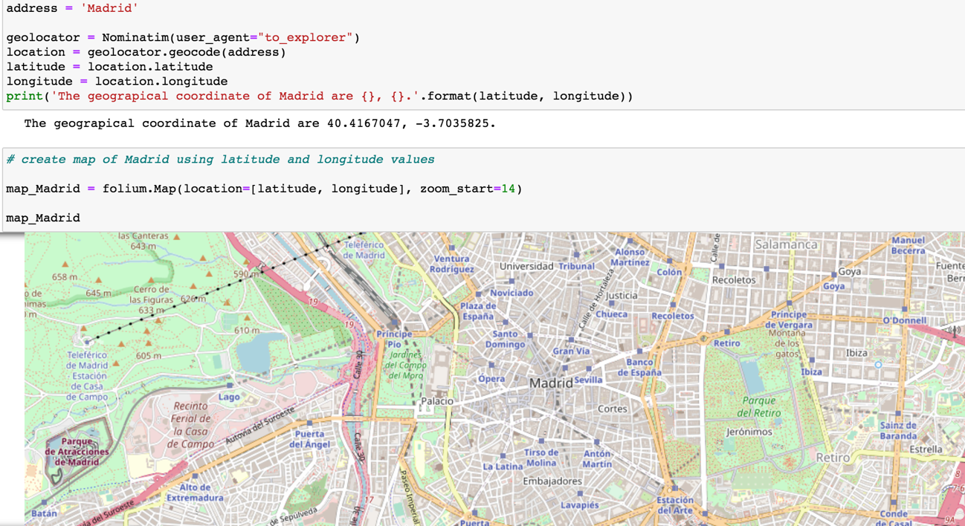

Second we obtain the data of all the bars in the city center of Madrid in foursquare:

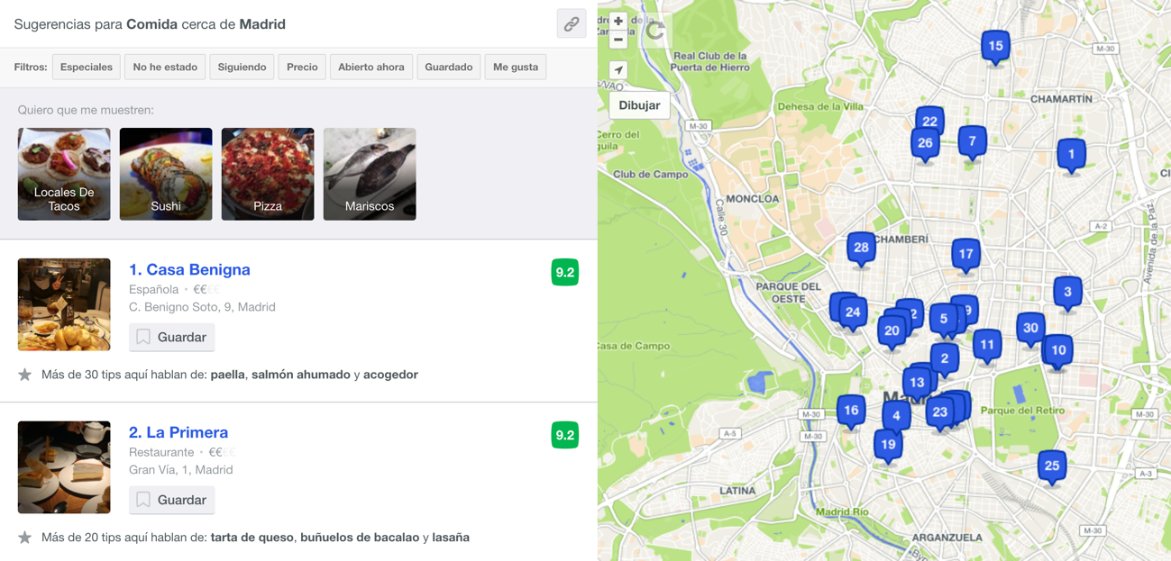

There are not much bar registered in foursquare in comparison with the reality (I think this website is not very known in Spain yet). But as this is an example I will perform the practice with they.

Now, we need to evaluate what neighborhoods has more bars concentration.

It is easy to check with the data that one correct assumption is “when you get closer to the center there is more concentration of bars”

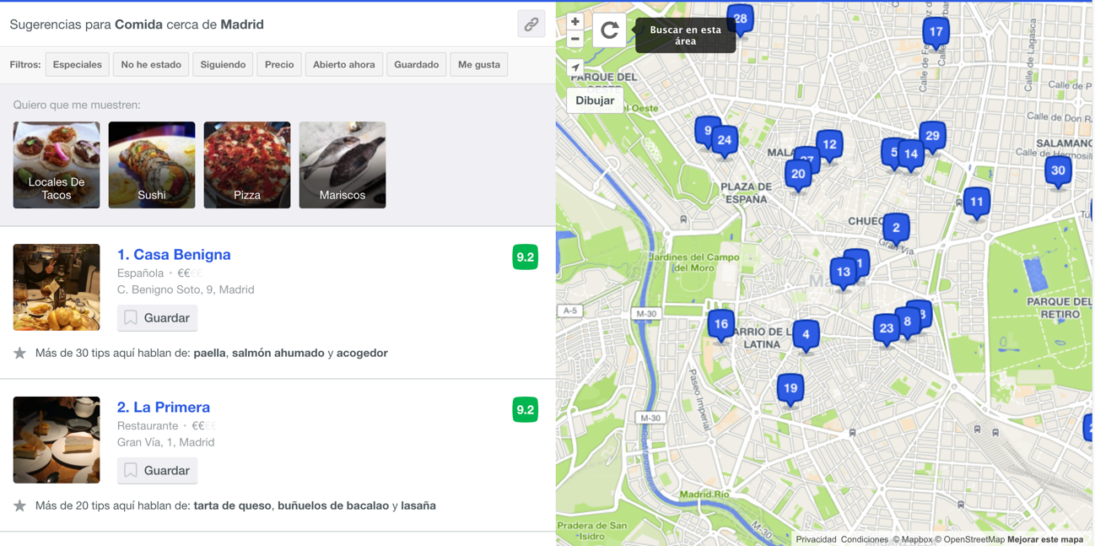

So the 3 neighborhoods candidates to establish the new bar should be:

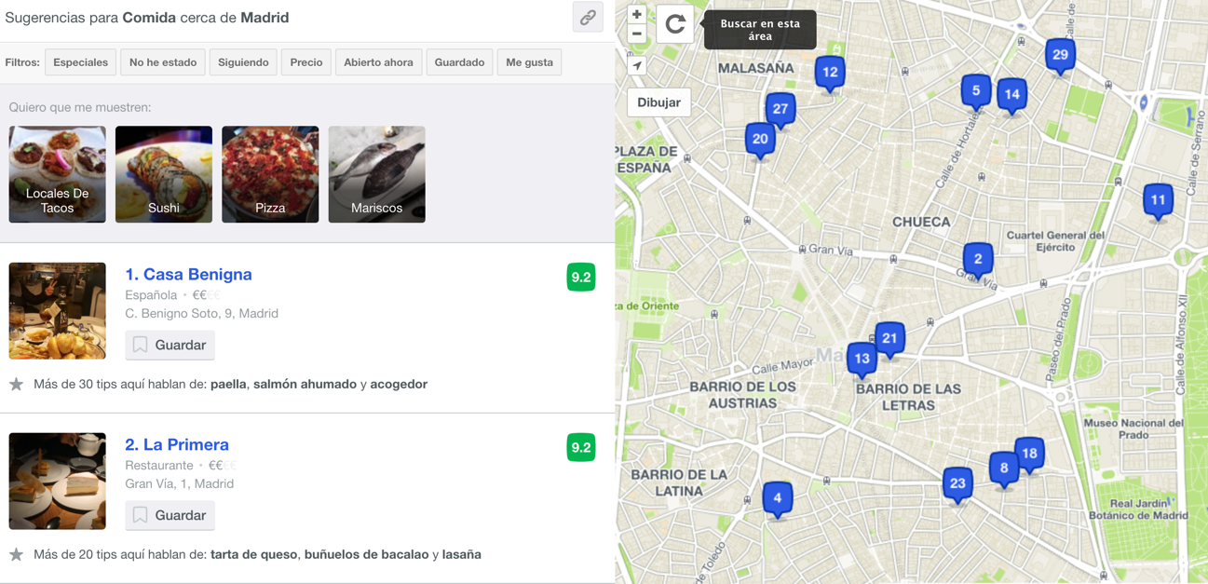

“Barrio de las Letras”, ”Chueca” y “Malasaña”.

Then, we need to check the local for sale m2 prices.

For that we use [www.idealista.com](http://www.idealista.com), a Spanish website of real state.

It is a very useful website due to have a interactive tool that allow you to paint our own area of interest:

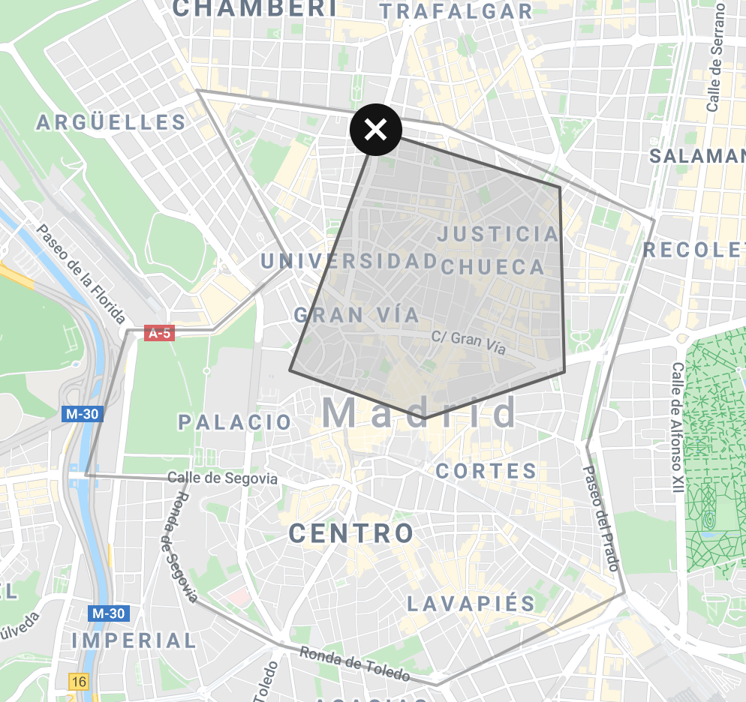

It is possible also filter the price and the m2

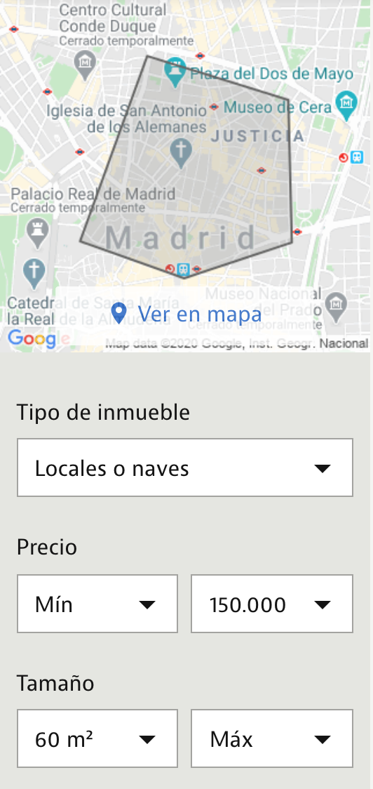

We filter the results by neighborhood and price, with the maximum price of 150.000€

In this case, we only obtain 1 result:

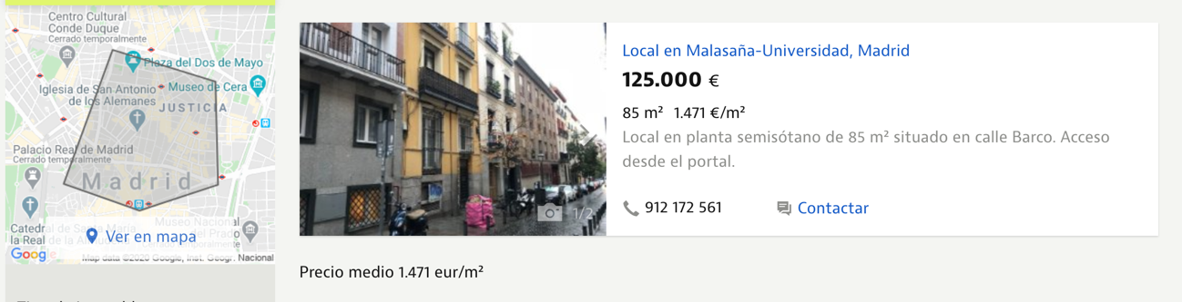

## Model

For the example that I choose, unfortunately, it is no necessary to make any model due to there is no big quantity of data.

But, as data scientist, I should iterate in the problem until find the optimum solution to my client. So I make different searches, changing the filter parameters.

In these case, I will recommend to him, that if he wish to start a new bar buying a local in Madrid should consider: or upgrade the budget or move to other non-center neighborhood.

These are my arguments:

If the filter has been modified up to 500.000€, the locals available are 37:

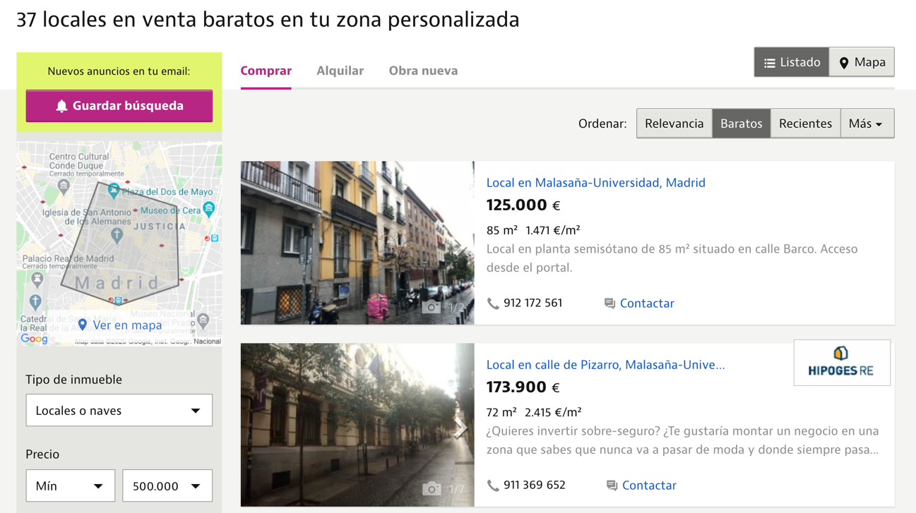

Or, if we amplify the search area, the locals available are 38:

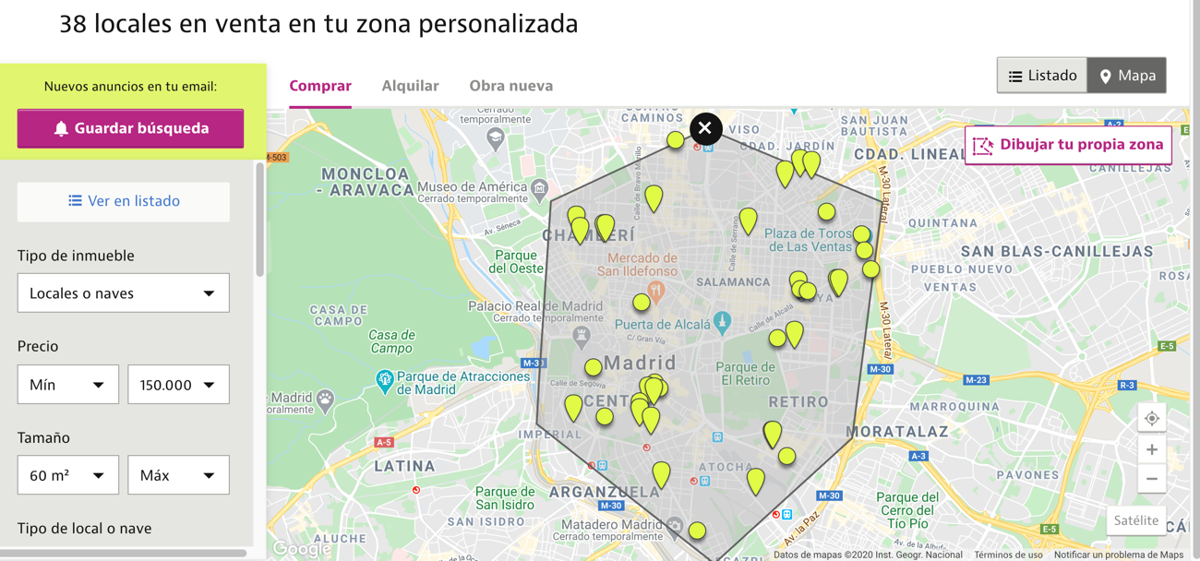

In these cases we could list all the main data of the locals available and load into a .csv in order to compare the best local taking into account:

-Location

-Price/m2

-Distance to the next bar

-Average age of the users of the bar in the neighborhood

## Conclusions

I will assume that the client accept the first option, increase the budget.

So the model shows how when you get closer to the center there is more concentration of bars, but the price/m2 increases exponentially.

Also, an important conclusion that had not taking into account at the beginning of the project, is that more than 30% of the users of the bars in the city center are foreign people. So it is very important maintain a good score in webs like foursquare due to the foreign people search the locals by internet.

The locals proposed to buy is the next:

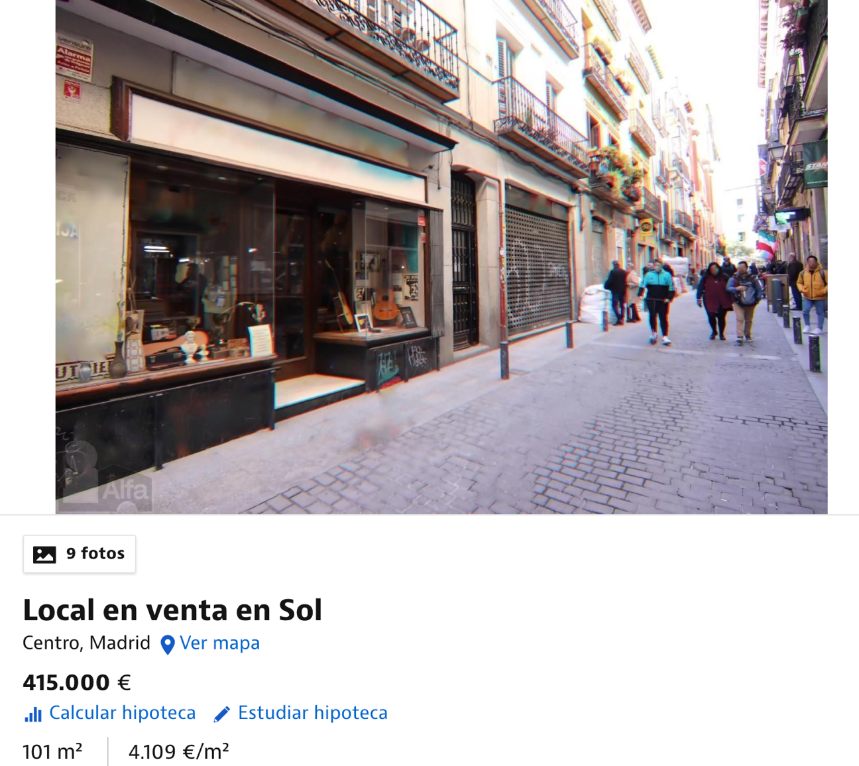

It is an old haberdashery, with the fourth best price/m2 in the area, just at 200 meter of the city center and with many style.

